The Oliver McGowan Mandatory Training on Learning Disability and Autism Tier 2

Learning disability session

Delegate handbook

Version 1.0 – July 2024
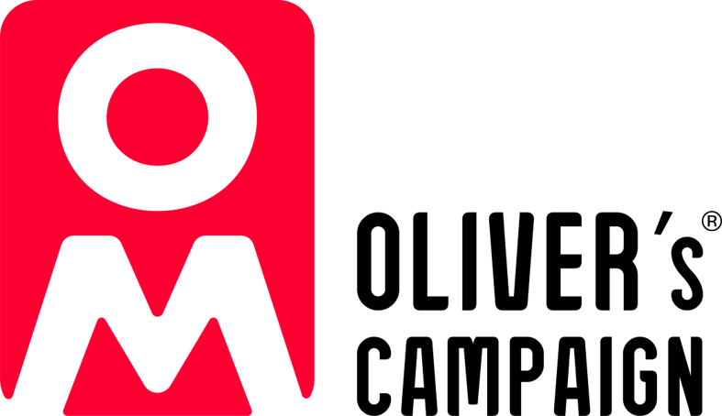
Copyright © NHS England 2024

Contents
Overview 3
Background 3
Course aim 3
Learning outcomes 3
Session outline 3
Tier 2 learning disability session 4
Thinking about Oliver’s Story 4
What is learning disability? 4
What is intelligence? 5
Mencap Myth Busters 6
Film: Meet Claire and Jada 6
Unconscious bias 6
Learning from Lives and Deaths (LeDeR) 2022 7
Film: Meet Blake or Meet Luther 9
Constipation 9
Diagnostic overshadowing 10
Key legislation and standards 10
Adapting our practice – reasonable adjustments and health checks 11
Adapting our practice – reasonable adjustments and communication 11
Health and hospital passport 12
Books Beyond Words 12
Further resources 12
References 14

Overview

Background
The training is named after Oliver McGowan. Oliver was a young man whose death shone a light on the need for staff to have training to better understand and respond to the needs of autistic people and people with a learning disability. Its ambition is to ensure health and social care workforce have the right skills and knowledge to provide safe, compassionate and informed care to autistic people and people with a learning disability.
Developed as a result of “Right to be Heard”, the government’s response to the consultation on mandatory training on learning disability and autism for health and social care staff.
In the Health and Care Act 2022 the government introduced a requirement for CQC-registered service providers to ensure their employees receive learning disability and autism training appropriate to their role.

Course aim
Enhance learners’ understanding of autism, best practice in a health and social care setting and understand how this is supported by current legislation.

Learning outcomes
- Understand the lives and experiences of people with a learning disability and recognise their strengths and contributions.
- Explore factors which impact on the quality of care and support of people with a learning disability.
- Understand the key findings from the Learning from Lives and Deaths reviews (LeDeR).
- Know what reasonable adjustments are and how to make them.

Session outline
- Remembering Oliver’s story
- What having a learning disability means
- Unconscious bias
- Learning from lives and deaths
- Diagnostic overshadowing
- Important laws and standards (Human Rights Act, Mental Capacity Act, DNACPR, advance care planning)
- Adapting our practice – reasonable adjustments and communication

Tier 2 learning disability session

Thinking about Oliver’s Story
During the elearning session you completed before attending today, you will have learnt from Paula McGowan (Oliver’s mother) about Oliver’s story. In small groups discuss your learning with others in your group and use the space below to record your recollections.

What is learning disability?
There are about 1.5 million people with a learning disability in the UK. Learning disability is defined by the following criteria.
- Impaired intelligence: a significantly reduced ability to understand new or difficult information, to learn new skills as well as...
- Impaired social functioning: a reduced ability to cope independently.
- Both of which started before adulthood with a lasting effect on development.
People with a learning disability are also more likely to have co-existing conditions such as
- Mental health problems – Studies show that people with a learning disability are twice as likely than the general population to have a mental health problem.
- Epilepsy – Epilepsy is more common in people with a learning disability than in the general population. About 1 in 3 people (32%) who have a mild to moderate learning disability also have epilepsy. The more severe the learning disability, the more likely that the person will also have epilepsy. Around 1 in 5 people (20%) with epilepsy also have a learning disability.
- Autism – 29% of people with a learning disability are also diagnosed as autistic.
- Cerebral palsy (CP) – not all people with CP have a learning disability, however according to the NHS approximately half of children with a learning disability have cerebral palsy.
- Sensory impairments – It has been estimated that visual impairment is ten times more prevalent in people with a learning disability, and hearing impairment is anything from 40 to 100 times above the rate in the general population.

What is intelligence?
The use of IQ Tests rarely if ever, happens in the diagnosing of a learning disability. IQ tests can be unreliable and can be culturally biased and also encourage a medicalised way of thinking about the person. They can encourage biases and assumptions to be made about a person’s ability, by focussing on intellectual deficits and inabilities rather than on what can be achieved and learnt with appropriate support and the right environment.
If intelligence doesn’t mean IQ, then what is it?
According to Dr Howard Gardner, a Harvard psychologist and researcher in educational psychology, intelligence is a multifaceted concept comprised of nine distinct intellectual modalities.
Naturalistic | Chef, botanist, vet
Musical | Musician, composer, conductor
Existential | Philosopher, theologist
Logical | Mathematician, detective, scientist
Spatial | Architect, sculptor, painter, pilot
Intra-personal | Coach, spiritual leader, psychologist
Interpersonal | Social worker, actor, teacher
Linguistic | Journalist, public speaker, poet
Kinesthetic | Dancer, athlete, surgeon, craftsperson
Multiple Intelligence Theory – Howard Gardner
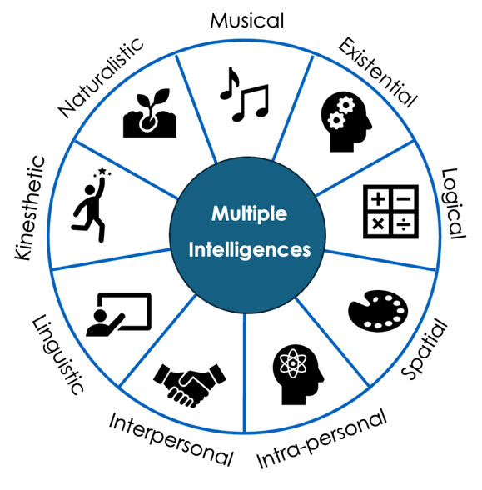

Look at Gardner’s Multiple Intelligence Theory and think of…
One thing you are good at
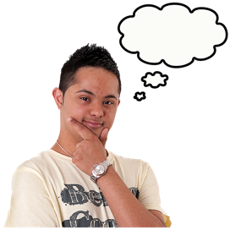
One thing you are not so good at

Mencap Myth Busters
Mencap Myth Busters are a team of ambassadors championed by Mencap to show the world what having a learning disability means today, and include athletes, activists, business owners, actors, a model, a dancer, a football coach and more.
Mencap’s Myth Busters are just some of the examples of the amazing things all people with a learning disability can achieve with the right opportunities and support.

Film: Meet Claire and Jada
You can use this space to make notes on the film.

Unconscious bias
Unconscious bias refers to a bias that we are unaware of, and which happens outside of our control. It is a bias that happens automatically and is triggered by our brain making quick judgments and assessments of people and situations, influenced by our background, cultural environment, and personal experiences.
Our assumptions/prejudices/beliefs are not facts and are always clouded with either negative or positive biases based on our experiences. Worryingly, we might even be aware of some of these, but most often they are unconscious biases that require immediate reflection and adjustment to avoid discrimination. To reduce our unconscious biases, we first need to be aware of them.
There are different types of biases which can subconsciously influence how we think and act with the people who are around us. We all have biases; we just may not be aware of them.

- Ableism/disablism
- Affinity bias
- Attribution bias
- Beauty bias
- Conformity bias
- Confirmation bias
- Gender bias
- The contrast effect
- Ageism
- Name bias

Uncovering our unconscious biases
Project Implicit is a non-profit organisation and international collaboration between researchers who are interested in implicit social cognition (meaning thoughts and feelings outside of conscious awareness and control). The goal of the organisation is to educate the public about hidden biases and to provide a “virtual laboratory” for collecting data on the internet. https://implicit.harvard.edu/implicit/takeatest.html
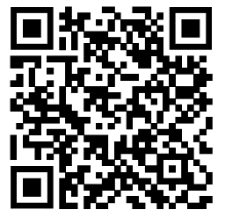
In their website they have a wide range of Implicit Association Test (IAT) from a list of possible topics. Completing some of these tests will help you identify what your unconscious biases are, so that you can then begin taking proactive steps to address them. You can access these tests via the QR code on the left after today’s training.

After completing one or more implicit association tests, use the box below to reflect on what you have found out about yourself.
What key things did you find out about yourself and your biases?
How do these things make you feel?
What steps can you take to address any biases you may have?

Learning from Lives and Deaths (LeDeR) 2022
Learning disability are not fatal conditions and yet, often due to unconscious biases, assumptions and prejudices, people with a learning disability do not get the same health and social care attention afforded to non-learning-disabled people…
“Learning disabilities [sic] are not fatal conditions and should never be used as a cause of death.” (LeDeR, 2020)
The LeDeR programme, funded by NHS England and NHS Improvement, was established in 2017 to improve healthcare for people with a learning disability and autistic people. LeDeR aims to:
- Improve care for people with a learning disability and autistic people.
- Reduce health inequalities for people with a learning disability and autistic people.
- Prevent people with a learning disability and autistic people from early deaths.
LeDeR summarises the lives and deaths of people with a learning disability and autistic people who died in England in annual reports.

Here are some brief facts from the 2022 LeDeR report.
LeDeR were told about 3,648 people with a learning disability who died in 2022. 55% of these were men and 45% were women. 4/10 people with a learning disability were still alive at the age of 65 compared to 9/10 for people without a learning disability. This means that men with a learning disability usually died 20 years earlier and women usually died 23 years earlier while autistic adults with a learning disability usually die 28 years younger. Of the 3,684 people with a learning disability who died in 2022
- 13% died of health problems that they have had all their lives, from when they were babies.
- 1% died of cancer.
- 8% died of flu and lung infections (pneumonia).
- 6% died of cerebral palsy and paralysis.
- 6% died of heart problems.
- 6% died of COVID-19.
- The others died of all sorts of other things.
Most people with a learning disability (90%) had some care which was good, but some people (10%) did not have any good care compared to 30% in 2021.
People from all ethnic minority groups died at a younger age in comparison to people of white ethnicity, when adjusting for sex, region of England, deprivation, place of death, and type of accommodation.
People with epilepsy are much more likely to die younger. Epilepsy was the long-term condition that was most strongly associated with dying at a younger age. This was followed by deep vein thrombosis, and degenerative diseases.
Almost half the people with a learning disability who died, died an avoidable death compared to less than a quarter of people without a learning disability. This means that people with a learning disability are twice as likely to die before their time.

Film: Meet Blake or Meet Luther
You can use this space to make notes on the film.

Constipation
People with a learning disability, especially those with a profound and multiple learning disability, are at much greater risk of experiencing constipation, and being prescribed laxatives. Constipation can become extremely dangerous if left untreated and can lead to serious illness and death.
Why people with a learning disability are likely to experience constipation (mention any of the below that are not brought up by the group):
- Reduced physical mobility – due to associated physical health conditions.
- Lack of access to exercise facilities.
- Prescribed medication such as antipsychotic, antidepressant and anticonvulsant medication that can all have a negative effect on bowel movement.
- Diet – limited diet choices, options, lack of knowledge or support for healthy eating.
- Inadequate fluid intake – particularly for people who need support with drinking or who do not like going to the toilet.
- Specific genetic conditions (e.g. Prader-Willi syndrome) that affect appetite.
- Other medical conditions that exacerbate constipation include hypothyroidism, depression and diabetes (which are all found at higher rates in people with a learning disability).
- People with down syndrome or cerebral palsy have an increased risk of constipation.
- Inappropriate toileting facilities or a lack of privacy or time to use them can cause constipation.
- Disruption in someone’s routine or changes to their care or environment can all negatively affect bowel habits.
- Ignoring or not recognising the urge to pass stool/defecate.

Diagnostic overshadowing
Occurs when a health professional makes the assumption that the behaviour of a person with a learning disability is part of their disability without exploring other factors such as biological determinants.
“Once a diagnosis is made of a major condition there is a tendency to attribute all other problems to that diagnosis, thereby leaving other coexisting conditions undiagnosed.” Royal College of Nursing Bulletin (2021) cited Neurotrauma Law Nexus
Diagnostic overshadowing is particularly pertinent when new behaviours develop or existing ones increase. People with a learning disability have a much higher risk of experiencing a variety of diseases or conditions, so it is vital that physiological or pathological causes of these behavioural changes are explored. If they are not, people with a learning disability can suffer poor care and avoidable deaths may even occur.


Oliver did not have a diagnosis of psychosis or a mental illness; he had cerebral palsy, epilepsy, a mild learning disability and autism. We strongly believed that doctors were misunderstanding Oliver’s normal autistic behaviour. We tried many times to explain this to them, but they would not listen. The effects on Oliver were catastrophic.
Paula McGowan, 2023)

Key legislation and standards
Your pre-course reading material contained very important information about key legislation and standards which can not be covered in depth on the course itself.
Please refer back to this information for more details on:
- Human Rights Act
- The Mental Capacity Act
- Advance care planning
- The Mental Capacity Act and advance care planning
- Do not attempt cardiopulmonary resuscitation – DNACPR
These standards and legislation are also key to understanding Oliver’s story and how to provide good care and support to people with a learning disability. Delegates can speak to their employer if they need further training on these for their roles.

Adapting our practice – reasonable adjustments and health checks
Annual health checks and cancer screenings
Everyone over 14 who is on their doctor’s learning disability register has an annual health check. An annual health check can help you stay well by talking to a doctor or nurse about your health and finding any problems early, so they can be sorted out.
Avoidable deaths appear to increase around the age of 50, so earlier interventions for preventable and avoidable causes of death may be necessary. These may include earlier screening ages, continued prioritisation for and awareness of vaccinations, and ongoing provision of annual health checks (LeDeR 2022)
- The Equality Act (2010) says that organisations need to take steps to remove barriers faced by people with a disability.
- The Equality Act calls this the duty to make reasonable adjustments.
- Reasonable adjustments are usually small changes that can make a big difference to a person with a disability.

Adapting our practice – reasonable adjustments and communication
It is always important to find out from the person themselves about what they need or seek advice from their family or carers about the best way you can support them. However, here are some examples of reasonable adjustments for people with a learning disability.
- Speak clearly and use simple words. Don’t be patronising but do check understanding. Don’t make assumptions about someone’s understanding.
- Take your time – people with a learning disability may need longer than other patients to understand information or to make themselves understood.
- Be flexible with appointment times – hospitals can be noisy and confusing places Giving an appointment at the start or end of the day when it is quieter may help.
- Providing a quiet place to wait. Waiting tooms can be noisy, busy and confusing. A quite place for them to sit and wait can help people remain calm and relaxed.
- Make sure information is accessible and provided in a way that they can understand. Please see appendix for further resources.
All publicly funded NHS and social care providers must meet the Accessible Information Standard (2016) as also determined by both to the Equality Act (2010) and the Health and Social Care Act (2012). The Standard aims to make sure that people who have a disability, impairment or sensory loss get information that they can access and understand, and any communication support that they need from health and care services. The Standard tells organisations how they should make sure that patients and service users, and their carers and parents, can access and understand the information they are given. This includes making sure that people get information in accessible formats. The Standard also tells organisations how they should make sure that people get support from a communication professional if they need it, and about changing working practices to support effective communication (NHS England, 2017).

Health and hospital passport
A health passport or hospital passport is a personalised record of people with a learning disability and autistic people’s long term health needs, how they communicate, what is important to them about their care and support and what they like and dislike. They are brought by the patient to hospital or other healthcare setting and are used by healthcare staff to quickly find out about the person and their healthcare needs.

Books Beyond Words
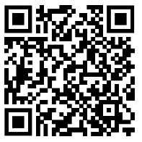
Books Beyond Words are full-colour picture books that address some of the problems in understanding experienced by people with intellectual and communication difficulties. By telling the whole story in pictures, they help people to prepare for an event or re-visit something that has happened, such as going to hospital. They are able to relate the pictures to their own experiences, without being distracted or confused by accompanying text. The pictures share information, but they also illustrate emotions relevant to the topic or experience.

Further resources
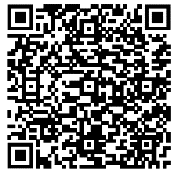 | Accessible Information Standard (NHS England)  Making health and social care information accessible  https://www.england.nhs.uk/about/equality/equality-hub/patient-equalities-programme/equality-frameworks-and-information-standards/accessibleinfo/
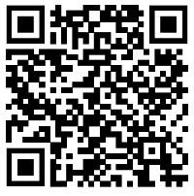 | Change People  Free Easy Read resources  https://www.changepeople.org/blog/december-2016/free-easy-read-resources
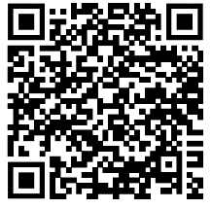 | Collection – Reasonable adjustments for people with a learning disability (Public Health England)  This series of guidance shares information, ideas and good practice in making reasonable adjustments for people with a learning disability in specific health service areas. It is aimed at health and social care professionals and family members who provide support for, or plan services used by, people with a learning disability. There is also an easy-read summary for each service area.  https://www.gov.uk/government/collections/reasonable-adjustments-for-people-with-a-learning-disability
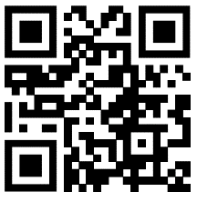 | Easy Health  Accessible information on health – an online library of accessible health information with simple words, clear pictures and films.  www.easyhealth.org.uk
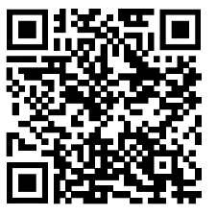 | Improving Health and Lives – (NDTi)  Reasonable adjustment guidance on how to make services accessible to people with a learning disability.  https://www.ndti.org.uk/assets/files/IHaL_resources_pdf_links_Aug_2019.pdf
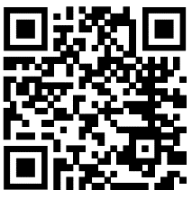 | Learning from Lives and Deaths – people with a learning disability and autistic people (LeDeR)  https://www.kcl.ac.uk/research/leder
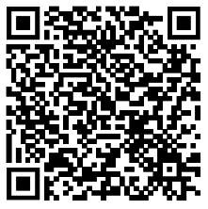 | Meet the Mencap Myth Busters  Busting myths about learning disability.  https://www.mencap.org.uk/about-us/mythbusters#:~:text=Mencap%20Myth%20Buster%20Sophie%20becomes,sexy%20in%20their%20skin%20...
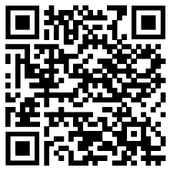 | Stopping over medication of people with a learning disability, autism or both (STOMP) – (NHS England)  https://www.england.nhs.uk/learning-disabilities/improving-health/stomp/

References
Equality Challenge Unit (2013) Unconscious bias and higher education. Caltech [online] Available at https://diversity.caltech.edu/documents/19785/unconscious-bias-and-higher-education-compressed.pdf [Accessed 16th May 2016]
NHS England (2017) Accessible Information Standard – Overview 2017/2018 [online] Available at https://www.england.nhs.uk/wp-content/uploads/2017/10/accessible-info-standard-overview-2017-18.pdf [Accessed 16th May 2024]
Royal Mencap Society (n.d.) Treat me well. Reasonable adjustments for people with a learning disability in hospital [online] Available at https://www.mencap.org.uk/sites/default/files/2018-06/Treat%20me%20well%20top%2010%20reasonable%20adjustments.pdf [Accessed 14th May 2024]

Copyright and usage of materials
Copyright © Health Education England 2024. All rights reserved.
No part of this publication may be reproduced, stored in a retrieval system of any nature, or transmitted, in any form or by any means including photocopying and recording, without the prior written permission of NHS England, the copyright owner.
Licences issued by the Copyright Licensing Agency or any other reproduction rights organisation do not apply. If any unauthorised acts are carried out in relation to this copyright work, a civil claim for damages may be made and/or a criminal prosecution may result.
This training material is for use by those authorised by NHS England. Those authorised may use them and must comply with the conditions of use put in place by NHS England which are subject to review.

